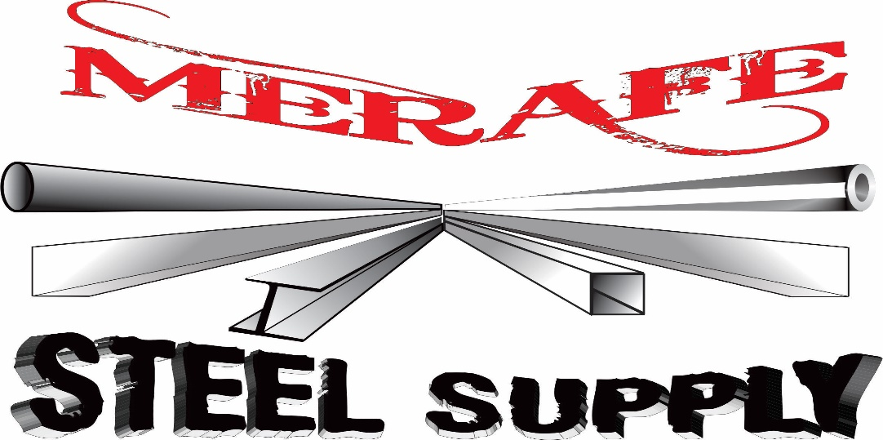

**Reg No.: 2013/141428/07**

**VAT NO.: 4120264405**

**COMPANY PROFILE**

**INDEX**

* COMPANY INFORMATION
* ORGANOGRAM
* COMPANY REGISTRATIONS
* QUALITY MISSION STATEMENT
* PRODUCT LIST AND DESCRIPTION
* CLIENTELE LIST
* ATTACHMENTS-
* BBBEE CERTIFICATE
* TAX CLEARANCE
* REGISTRATION CERTIFICATE
* CIBD CERTIFICATE
* LETTER OF GOOD STANDING
* SHARE CERTIFICATE

1. **COMPANY INFORMATION**

REGISTERED NAME : MERAFE STEEL SUPPLY (PTY) LTD

PHYSICAL ADDRESS : **126** GENERAL HERTZOG STR

: THREE RIVERS

: VEREENIGING

: **1930**

POSTAL ADDRESS : **126** GENERAL HERTZOG STR

: THREE RIVERS

: VEREENIGING

: **1930**

EMAIL ADDRESS : [merafesteelsupply@gmail.com](mailto:merafesteelsupply@gmail.com)

TELEPHONE NUMBER : **016 931 0611, 016 4231203, 016 423 1364**

MOBILE **: 083 865 2533**

FAX NUMBER  **: 016 931 1995**

1. **ORGANOGRAM**

LUCAS MERAFE

OWNER

SALES&MARKETING

AARON & LUCKY

LUCAS MERAFE

FINANCIAL MANAGER

PRODUCTION

LUCKY MERAFE

ADMINISTRATION

LEBO HLANYANE

PLANNER&ESTIMATOR

LUCKY & DUMISANI

PROCUREMENT

LEBO HLANYANE

REPAIRS & REFURBISHMENT DUMISANI

MACHINING&ENG

LUCKY & DUMISANI

HYDRAULIC DIVISION

SAMMY SOSO

1. **COMPANY REGISTRATIONS**

Registration No.: 2013/141428/07

VAT No.: 4120264405

Tax No.: 9325722172

CIBD Registered: CRS No: 10200365

1. **QUALITY STATEMENT**

Merafe Steel Supply is continually striving to provide the highest possible service levels to its customers by continually improving costs and lead times whilst maintaining an emphasis on quality.

We strive to deliver consistent quality efficiently, and to deliver on time.

To do our utmost best to maintain a safe working environment.

We trust that we will remain a long term reliable partner for our valued clients.

1. **PRODUCT LIST AND DESCRIPTION**

Merafe steel is made up of different divisions, The General Steel and Engineering Work division, civil & construction, industrial cleaning, repair & refurbishment, engineering & machining, tools & mining equipment and Hydraulic Divisions.

**Specifications strictly according to your drawing/requirements.**

* **STEEL**

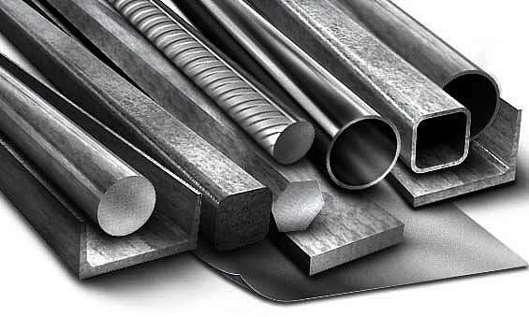

* **PIPES**

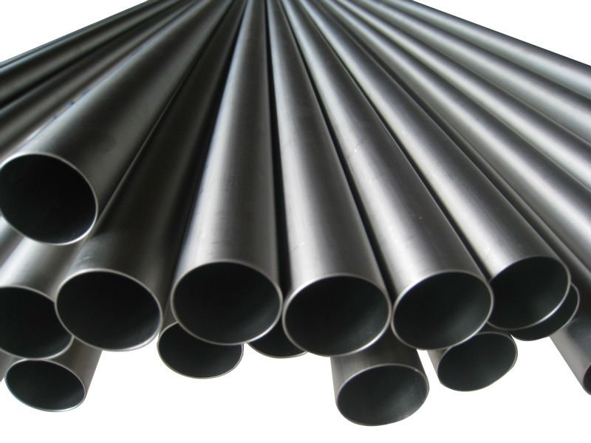

* **FITTINGS**

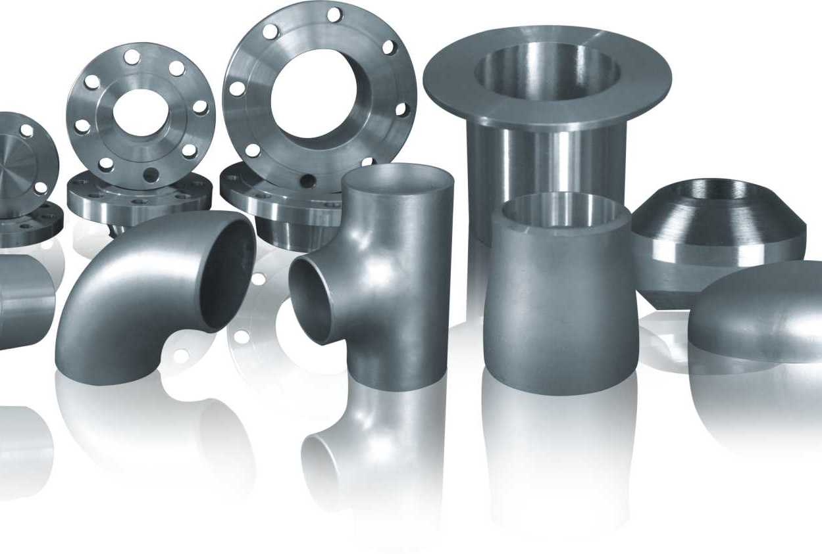

* **BOLTS & NUTS**

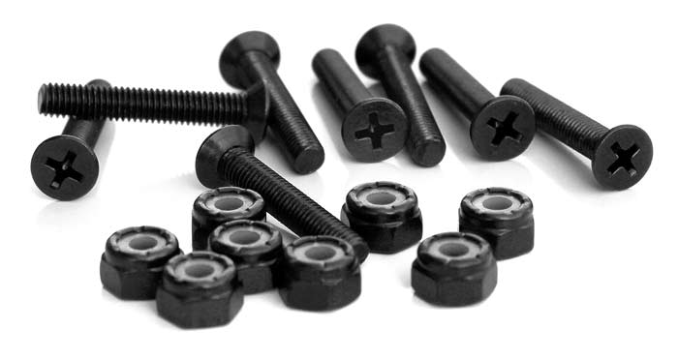

* **FABRICATION**

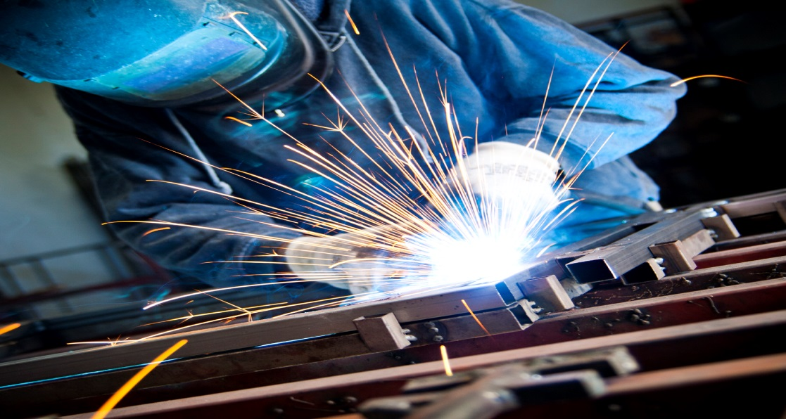

* **MACHINING**

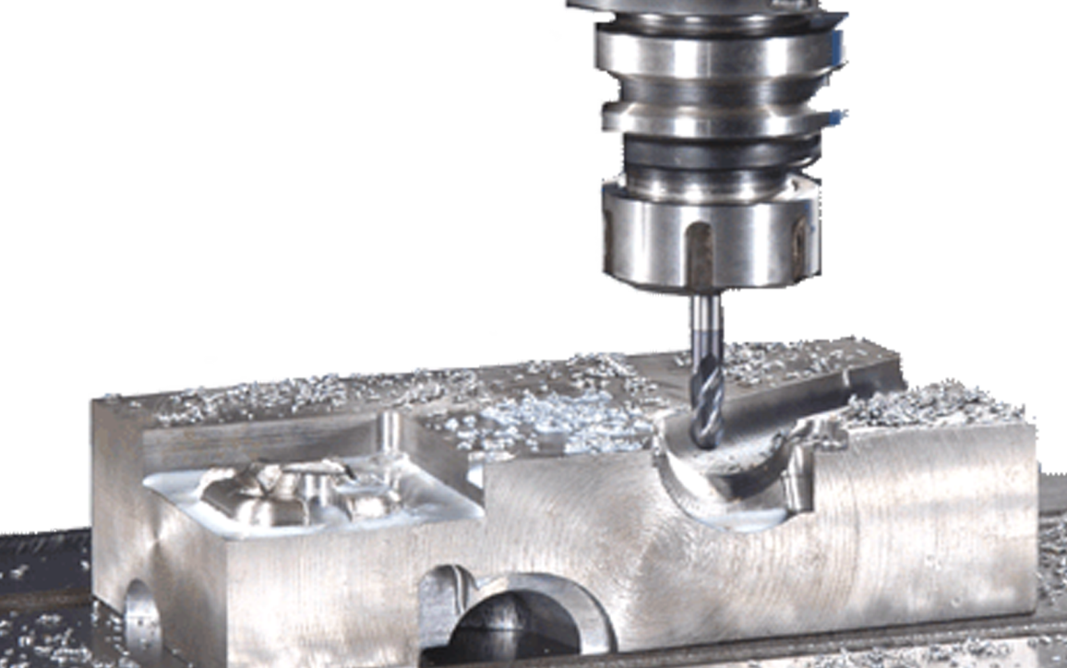

* **REPAIRS**

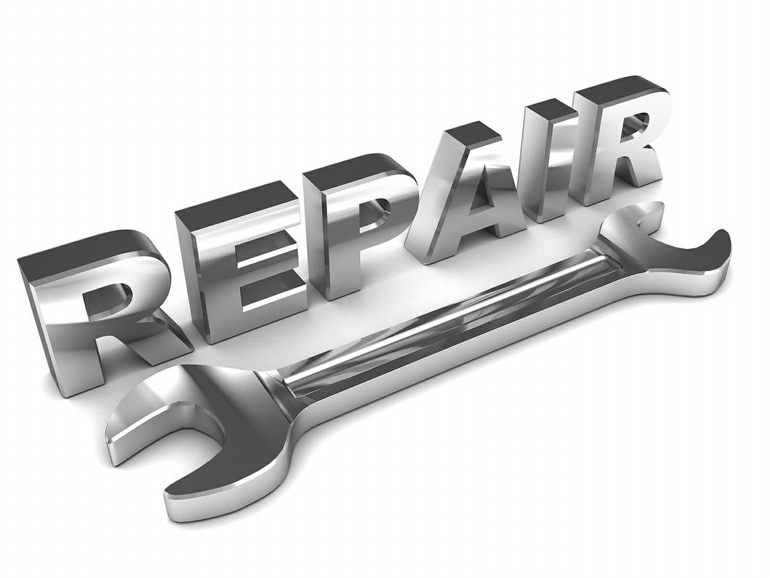

* **VALVE**

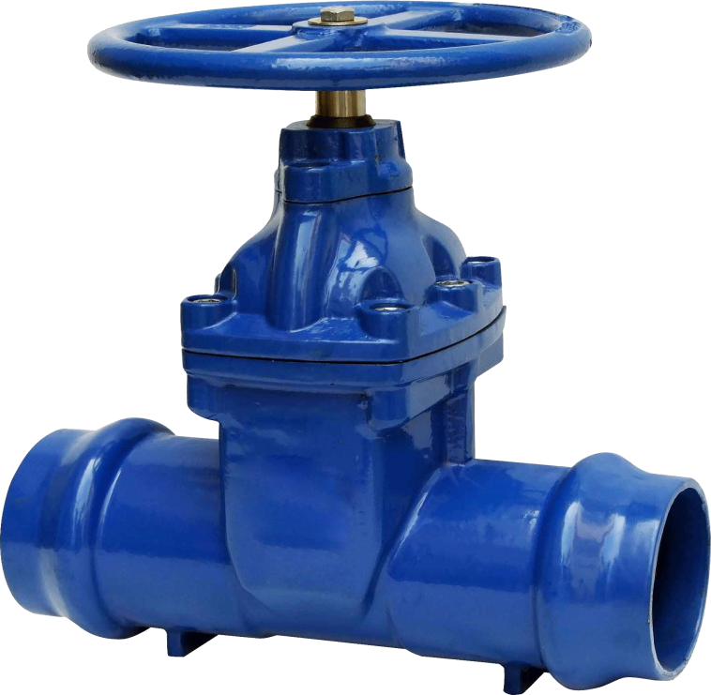

* **PUMPS**

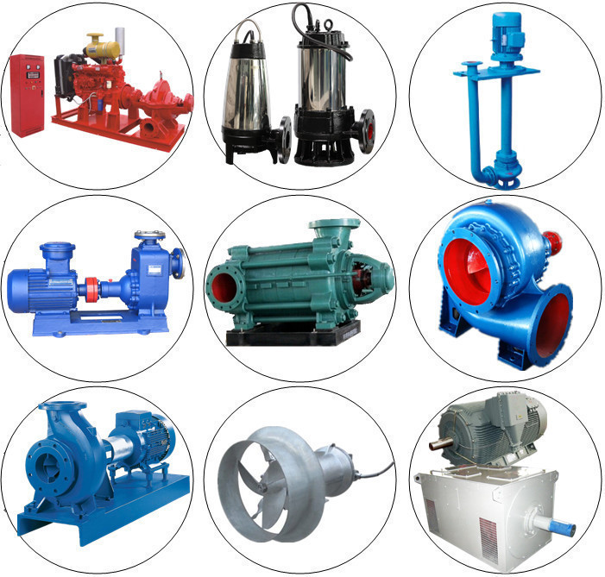

* **Safety Equipment’s**

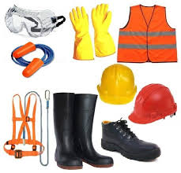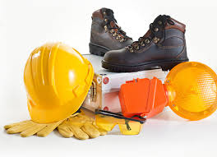

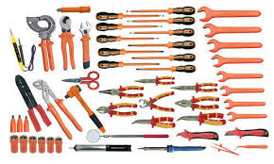

* **Hydraulic hoses and fittings**

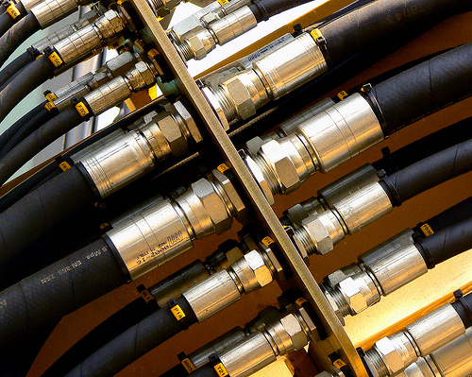

* **Hydraulic hoses**

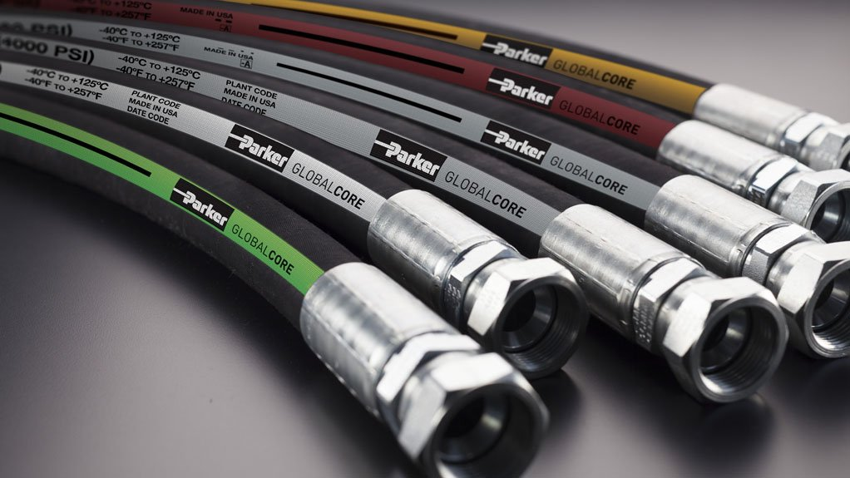

* **Hydraulic valves**

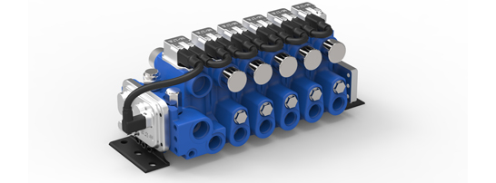 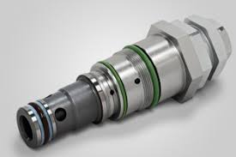

* **Hydraulic and Pneumatic cylinders**

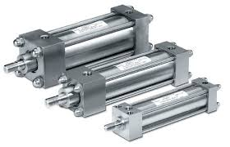 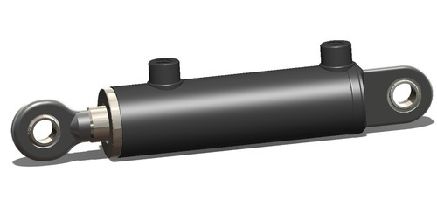

* **Reconditioning of cylinder**

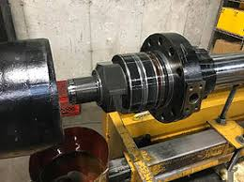

* **Seals and bearings**

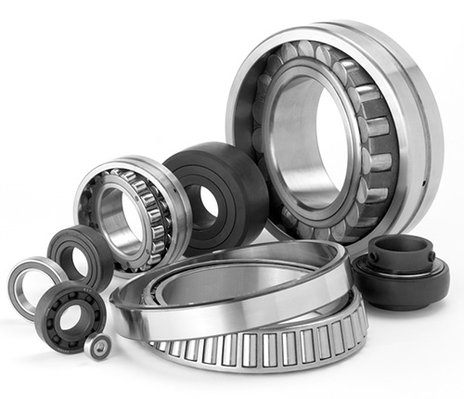

* **Hydraulic power packs**

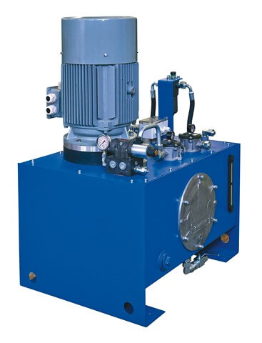

* **Vacuum Truck**

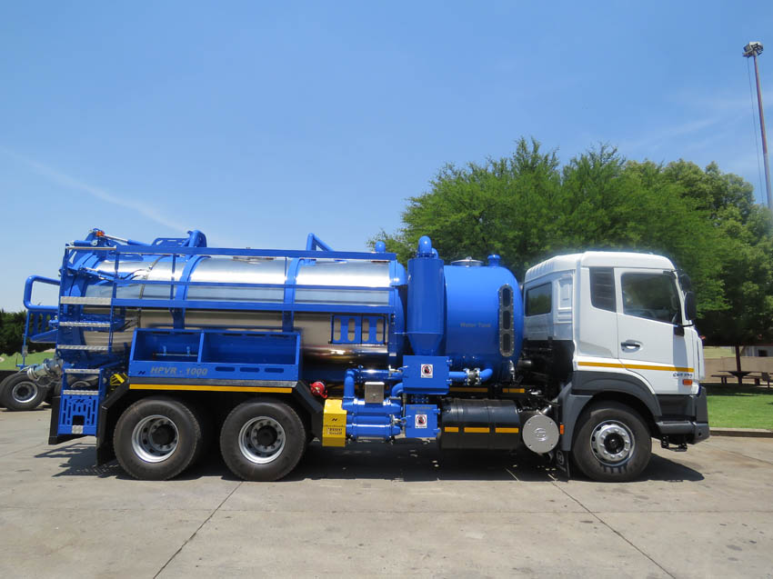

WE SPECIALISE IN THE FOLLOWING:

* **INDUSTRIAL CLEANING**
* **PLANT CLEANING**
* **HIGH PRESSURE CLEANING**
* **SUPER SUCKER WORK**
* **WASTE MANAGEMENT**
* **TRANSPORT OF DANGEROUS GOODS**
* **GENERAL ENGINEERING WORK**
* **Manufacturing, reconditioning, fabrication and installation of all the engineering work.**
* **Machine and engineering work**
* **Steel supplier : pipes and fittings**
* **Bolts and Nuts**
* **Plate and Gratings**
* **Expanded Metals**
* **Tubes and Hoses**
* **Structural steel : flat bar , Angle Iron , Channel , Beams Sq Bar, Round Bar, IBR Sheet, Special steel**
* **Stainless Steel : plate, pipes, fittings, bolt &nuts**
* **Profiles cut to size**
* **Handrails and Stanchion**
* **Safety Equipment’s**
* **Hydraulics**
* **Vacuum Truck to Hire**

1. **CLIENTELE LIST**

We have a large variety of Clientele which consists of:

* RAND WATER
* ESKOM
* TRANSNET
* LOCAL MUNICIPALITIES
* CERAMIC INDUSTRIES
* INTERCABLE PROPERTY INVESTMENTS
* JOHANNESBURG WATER
* MIDVAAL LOCAL MUNICIPALITY
* FEZILE MUNICIPALITY
* OMNIA
* AFRIMAT INDUSTRIAL MINERALS
* M-TEC
* GRAPHON
* PEGAUSIS
* VITRO
* **Tharisa Mineral Mine**
* **Royal Bafokeng Platinum Mine**
* **Siyanda Bakgatla Platinum Mine**